Sounds In Pictures
Students or groups are given one picture each and they challenge each other to find words with certain phonemes in. If one team finds a sound which the other team can't, it's a point. This is good practice of both vocabulary and pronunciation.
For example:
Group A: OK, we have /r/ with receptionist.
Group B: We don't have /r/. Oh, yes. We have /r/ with roof.
The game can be adapted for any level of vocabulary. Try to use pictures with a similar number of objects in them such as these two.

Picture A

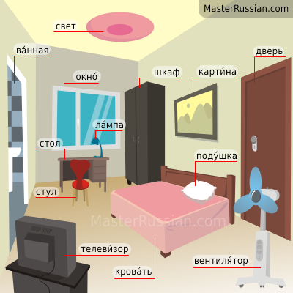

Picture B

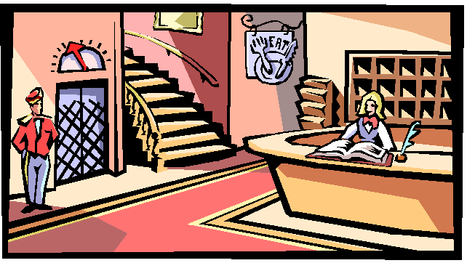

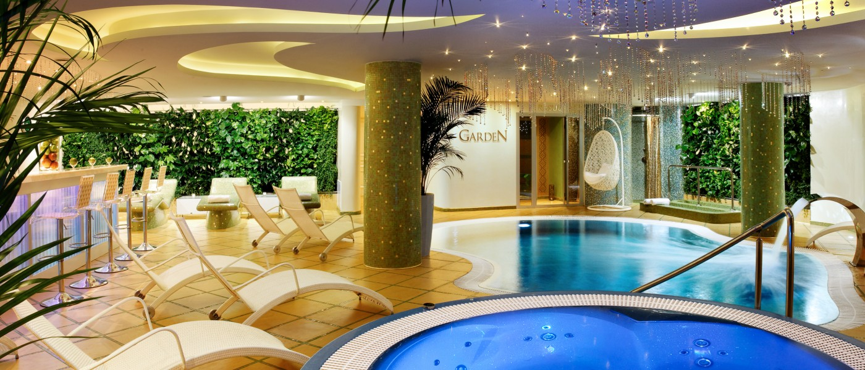

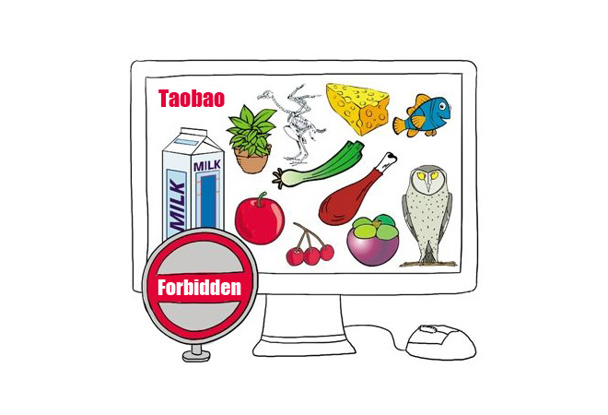

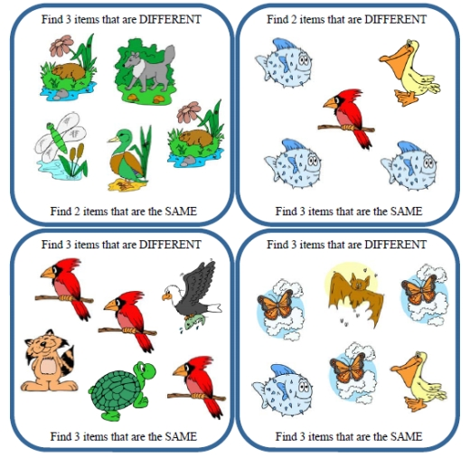

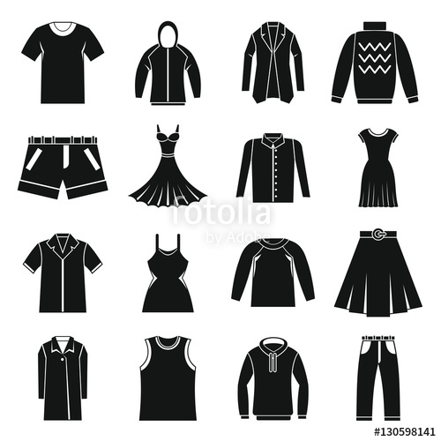
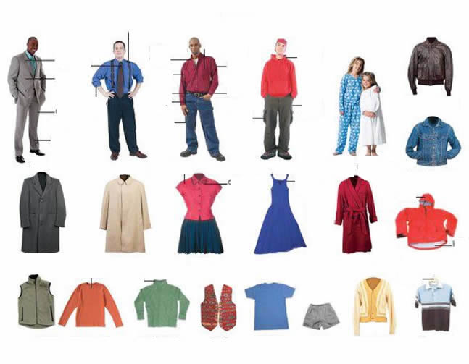

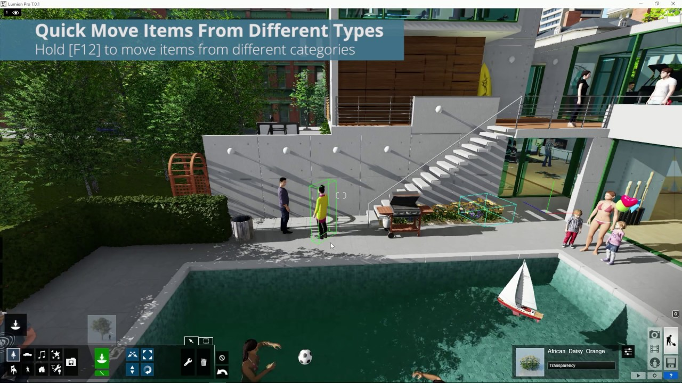

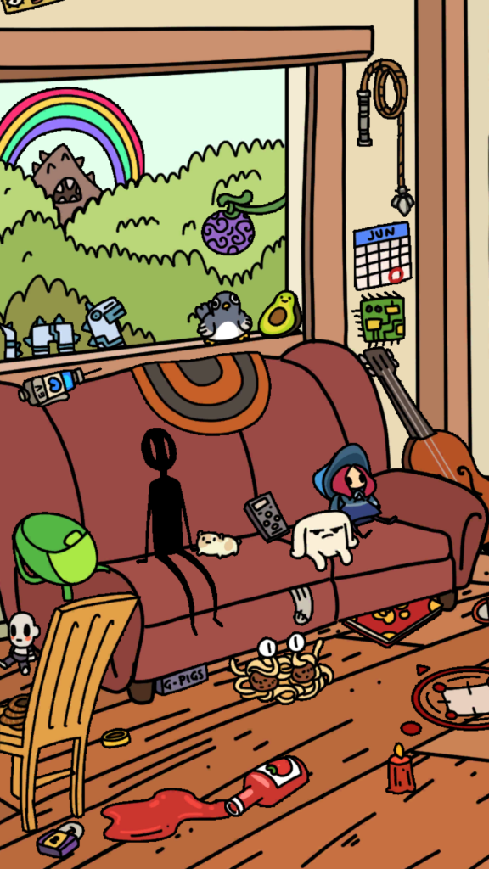
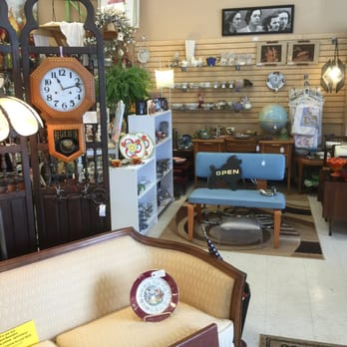
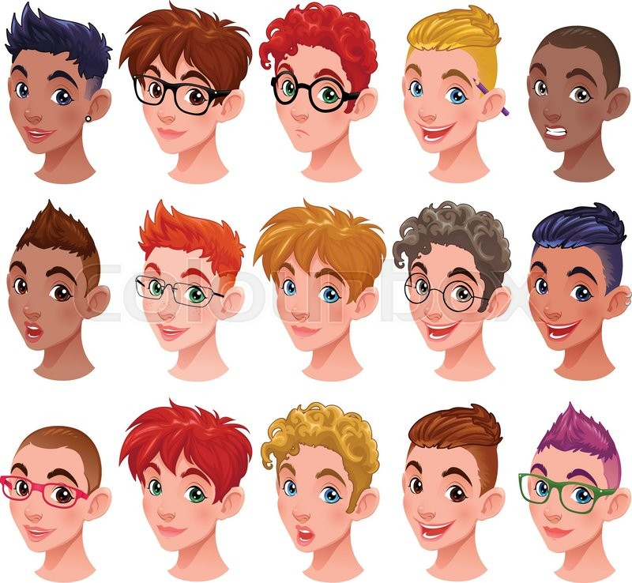

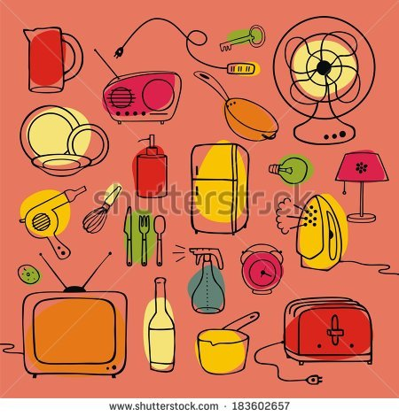

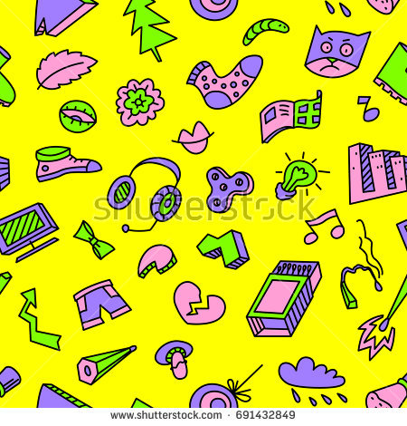

Find The Homophones
Which word has the same pronunciation as the question word?
1. sew
a) sir
d) saw
c) so
2. steel
a) still
b) steal
c) style
3. fair
a) fur
b) fear
c) fare
4. here
a) hair
b) her
c) hear
5. too
a) two
b) tar
c) toe
6. mail
a) mile
b) male
c) mill

7. wait
a) wheat
d) weight
c) white
8. bear
a) bare
b) beer
c) bar

9. lay / lie
True
False
10. fool / foal
True
False
11. floor / flaw
True
False
12. arm / harm
True
False
13. hour / our
True
False
14. tour / tower
True
False
15. air / heir
True
False
16. pane / pain
True
False

17. sea / see
True
False
18. no / now
True
False
19. cell / sell
True
False
20. fought / thought
True
False
21. out / ought
True
False
22. flour / flower
True
False
23. peace / piece
True
False
24. cat / cart
True
False

25. where / wear
True
False
26. sow / saw
True
False
27. sum / some
True
False
28. there / they
True
False
29. pip / peep
True
False
30. wood / would
True
False
31. write / right
True
False
32. thought / fort
True
False

Silent Letters Worksheet Which letter in these words is silent?
33. receipt
- c
- i
- p
- t
34. doubt
- u
- b
- t
35. gnome
- g
- n
- m
36. halves
- h
- l
- v
- s
37. whale
- w
- h
- l
38. wrong
- w
- r
- n
- g39. ballet
- b
- l
- t40. excerpt
- x
- c
- p
- t
Silent Letters Worksheet 2
Which letter in these words is silent?
41. dumb
a. d
b. m
c. b
42. aisle
a. s
b. l
43. raspberry
a. s
b. p
c. b
d. r

44. champagne
a. c
b. m
c. g
d. n
45. climb
a. l
b. m
c. b
46. autumn
a. a
b. m
c. n
47. ghost
a. g
b. h
c. s
d. t
48. knife
a. k
b. n
c. f

Which one is different?
It may be a vowel or one of the consonants.
1. a) mouse b) now c) taught d) howler
2. a) new b) sue c)do d) sew
3. a) think b)breath c)breathe d)thumb
4. a) name b)lamp c)pay d)stain
5. a) would b) wood c) could d)moon
6. a) see b) men c) mean d) seen
7. a) use b) useless c) useful d) be used to
8. a) come b) up c) won d) stool
9. a) stoke b) stop c) odd d) dot
10. a) computer b) stick c) nice d) bark

Silent Letters Worksheet 3
Which letter in these words is silent?
11. align
a. l
b. g
c. n

12. Wednesday
a. w
b. d
c. n
d. s

13. castle
a. s
b. t
c. l

14. thumb
a. t
b. m
c. b

15. rendezvous
a. n
b. d
c. z
d. v

16. know
a. k
b. n
c. o
17. guest
a. u
b. s
c. t
18. sword
a. w
b. r
c. d

Word Stress Worksheet
Look at each of these words. Decide on which syllable the stress falls?
Example: about - 2nd syllable, biological - 3rd syllable.

19. receipt
a. 1st
b. 2nd

20. kitchen
a. 1st
b. 2nd

21. believable
a. 1st
b. 2nd
c. 3rd
d. 4th

22. deception
a. 1st
b. 2nd
c. 3rd

23. thirteen
a. 1st
b. 2nd

24. thirty
a. 1st
b. 2nd

25. tomato
a. 1st
b. 2nd
c. 3rd

26. bathroom
a. 1st
b. 2nd

Word Stress Worksheet

Look at each of these words. Decide on which syllable the stress falls?

Example: about - 2nd syllable, biological - 3rd syllable.

27. reception
a. 1st
b. 2nd
c. 3rd

28. comparison
a. 1st
b. 2nd
c. 3rd
d. 4th

29. potato
a. 1st
b. 2nd
c. 3rd

30. bedroom
a. 1st
b. 2nd

31. fourteen
a. 1st
b. 2nd

32. forty
a. 1st
b. 2nd

33. delicious
a. 1st
b. 2nd
c. 3rd

34. playful
a. 1st
b. 2nd

Word Stress Worksheet

Look at each of these words. Decide on which syllable the stress falls?

Example: about - 2nd syllable, biological - 3rd syllable.

35. personal
a. 1st
b. 2nd
c. 3rd

36. personnel
a. 1st
b. 2nd
c. 3rd

37. adjective
a. 1st
b. 2nd
c. 3rd

38. enhance
a. 1st
b. 2nd

39. Canadian
a. 1st
b. 2nd
c. 3rd
d. 4th

40. Japanese
a. 1st
b. 2nd
c. 3rd

41. psychology
a. 1st
b. 2nd
c. 3rd
d. 4th

42. politician
a. 1st
b. 2nd
c. 3rd
- 4th
Word Stress Worksheet

Look at each of these words. Decide on which syllable the stress falls?

Example: about - 2nd syllable, biological - 3rd syllable.

43. industrial
a. 1st
b. 2nd
c. 3rd
d. 4th

44. fantastic
a. 1st
b. 2nd
c. 3rd

45. today
a. 1st
b. 2nd

46. frightened
a. 1st
b. 2nd

47. energy
a. 1st
b. 2nd
c. 3rd

48. employment
a. 1st
b. 2nd
c. 3rd

49. certificate
a. 1st
b. 2nd
c. 3rd
d. 4th

50. independent
a. 1st
b. 2nd
c. 3rd
d. 4th

Consonant Phonemes: Odd One Out
Look at the following groups of words and the underlined consonant phonemes.
Which one is different from the others?
1. a) church b) Chester c)such d) ridge
2. a) shape b) hiss c) push d) passion
3. a) German b) justice c) chicken d) postage
4. a) yacht b) university c) major d) you
5. a) gate b) pig c) germs d) great
6. a) cat b) nice c) ceiling d) sensitive
7. a) think b) mother c) mammoth d) thanks
8. a) vision b) buzz c) zip d) lazy

Word Stress Worksheet
Look at each of these words. Decide on which syllable the stress falls?
Example: about - 2nd syllable, biological - 3rd syllable.
9. photo
a. 1st
b. 2nd
10. photography
a. 1st
b. 2nd
c. 3rd
d. 4th
11. photographic
a. 1st
b. 2nd
c. 3rd
d. 4th
12. decide
a. 1st
b. 2nd
13. decision
a. 1st
b. 2nd
c. 3rd
14. bakery
a. 1st
b. 2nd
c. 3rd
15. understand
a. 1st
b. 2nd
c. 3rd
16. attention
a. 1st
b. 2nd
c. 3rd

How many syllables are there in each word? Choose the correct answer.
17. monkey
a) 1
b) 2
c) 3
d) 4
18. relocation
a) 1
b) 2
c) 3
d) 4
19. magnet
a) 1
b) 2
c) 3
d) 4
20. slobs
a) 1
b) 2
c) 3
d) 4
21. characterise
a) 1
b) 2
c) 3
d) 4
22. travelling
a) 1
b) 2
c) 3
d) 4
23. rocket
a) 1
b) 2
c) 3
d) 4
24. trying
a) 1
b) 2
c) 3
d) 4
25. garden
a) 1
b) 2
c) 3
d) 4
26. caterpillar
a) 1
b) 2
c) 3
d) 4

How Many Syllables, Worksheet 2
How many syllables are there in each word? Choose the correct answer.
27. beginning
a) 1
b) 2
c) 3
d) 4
28. architecture
a) 1
b) 2
c) 3
d) 4
29. capitalise
a) 1
b) 2
c) 3
d) 4
30. octopus
a) 1
b) 2
c) 3
d) 4
31. liveliness
a) 1
b) 2
c) 3
d) 4

32. delicacy
a) 1
b) 2
c) 3
d) 4
33. elation
a) 1
b) 2
c) 3
d) 4
34. popular
a) 1
b) 2
c) 3
d) 4
35. nobody
a) 1
b) 2
c) 3
d) 4
36. deeper
a) 1
b) 2
c) 3
d) 4

How Many Syllables, Worksheet 3
How many syllables are there in each word? Choose the correct answer.
37. heater
a) 1
b) 2
c) 3
d) 4
38. window
a) 1
b) 2
c) 3
d) 4
39. animal
a) 1
b) 2
c) 3
d) 4
40. photograph
a) 1
b) 2
c) 3
d) 4
41. time
a) 1
b) 2
c) 3
d) 4
42. slipper
a) 1
b) 2
c) 3
d) 4
43. passionate
a) 1
b) 2
c) 3
d) 4
44. appreciate
a) 1
b) 2
c) 3
d) 4
45. goes
a) 1
b) 2
c) 3
d) 4
46. timer
a) 1
b) 2
c) 3
d) 4

How many syllables are there in each word? Choose the correct answer.
47. acceptation
a) 1
b) 2
c) 3
d) 4
48. ladybug
a) 1
b) 2
c) 3
d) 4
49. computer
a) 1
b) 2
c) 3
d) 4
50. enjoying
a) 1
b) 2
c) 3
d) 4

How Many Syllables, Worksheet 5
How many syllables are there in each word? Choose the correct answer.
1. adventure
a) 1
b) 2
c) 3
d) 4
2. splits
a) 1
b) 2
c) 3
d) 4
3. zipper
a) 1
b) 2
c) 3
d) 4
4. necklace
a) 1
b) 2
c) 3
d) 4
5. adults
a) 1
b) 2
c) 3
d) 4

6. impulsive
a) 1
b) 2
c) 3
d) 4
7. years
a) 1
b) 2
c) 3
d) 4
8. excitement
a) 1
b) 2
c) 3
d) 4
9. flying
a) 1
b) 2
c) 3
d) 4
10. dividend
a) 1
b) 2
c) 3
d) 4

How Many Syllables, Worksheet 6
How many syllables are there in each word? Choose the correct answer.
11. suitable
a) 1
b) 2
c) 3
d) 4
12. departmental
a) 1
b) 2
c) 3
d) 4
13. from
a) 1
b) 2
c) 3
d) 4
14. drives
a) 1
b) 2
c) 3
d) 4
15. pumpkin
a) 1
b) 2
c) 3
d) 4

16. victory
a) 1
b) 2
c) 3
d) 4
17. crafts
a) 1
b) 2
c) 3
d) 4
18. dinosaur
a) 1
b) 2
c) 3
d) 4
19. fried
a) 1
b) 2
c) 3
d) 4
20. walks
a) 1
b) 2
c) 3
d) 4

How Many Syllables, Worksheet 7
How many syllables are there in each word? Choose the correct answer.
21. bumblebee
a) 1
b) 2
c) 3
d) 4
22. won't
a) 1
b) 2
c) 3
d) 4
23. merriment
a) 1
b) 2
c) 3
d) 4
24. denying
a) 1
b) 2
c) 3
d) 4
25. eyes
a) 1
b) 2
c) 3
d) 4
26. frying
a) 1
b) 2
c) 3
d) 4
27. hamburger
a) 1
b) 2
c) 3
d) 4
28. ponytail
a) 1
b) 2
c) 3
d) 4
29. arbitrary
a) 1
b) 2
c) 3
d) 4
30. classes
a) 1
b) 2
c) 3
d) 4

Task #2: Write each line in normal English orthography.
1: [ðә tajm hæz cʌm]
2: [ðә wɑlrәs sed]
3: [tu tɑlk әv mɛni θɪŋz]
4: [әv ʃuz ɑnd ʃɪps]
5: [ænd silɪŋ wæx]
6: [әv kæbәgәz ænd kɪŋz]
7: [ænd wɑj ðә si ɪs bojlɪŋ hɑt]
8: [ænd wɛθәr pɪgz hæv wɪŋz]
Phonetics Practice Exercises I (Answers)
Linguistics 201
I. Write each of the following words in phonetic transcription.
1. heat [hit] 6. shrink [ʃrɪŋk]
2. stroke [strowk] 7. toque [tuk]
3. phase [fejz] 8. attentive [ətɛ́ntɪv]
4. chump [tʃʌmp] 9. flop [flɑp]
5. loonie [luni] 10. wrath [ræθ]
II. The following is a phonetic transcription of an excerpt of the poem "The Walrus and
the Carpenter", from Lewis Carroll's book Through the Looking Glass. Each line of the
poem contains one word that is transcribed incorrectly, at the phonemic or "broad"
level of transcription.
Task #1: Identify the word that has been transcribed incorrectly, and then write the
correct form of the transcription.
Task #2: Write each line in normal English orthography.
1: [ðə tajm hæz cʌm] Correction: [cʌm] → [kʌm]
Orthography: the time has come
2: [ðə wɑlrəs sed] Correction: [sed] → [sɛd]
Orthography: the walrus said
3: [tu tɑlk əv mɛni θɪŋz] Correction: [tɑlk] → [tɑk]
Orthography: to talk of many things
4: [əv ʃuz ɑnd ʃɪps] Correction: [ɑnd] → [ænd]
Orthography: of shoes and ships
5: [ænd silɪŋ wæx] Correction: [wæx] → [wæks]
Orthography: and sealing wax
6: [əv kæbəgəz ænd kɪŋz] Correction: [kæbəgəz] → [kæbədʒəz]
Orthography: of cabbages and kings
7: [ænd wɑj ðə si ɪs bojlɪŋ hɑt] Correction: [ɪs] → [ɪz]
Orthography: and why the sea is boiling hot
8: [ænd wɛθər pɪgz hæv wɪŋz] Correction: [wɛθər] → [wɛðər]

